# DATA BASE MANAGEMENT SYSTEM

PROJECT PROPOSAL : TOURSIM WEBISTE

INSTRUCTOR : MS QURAT-UL-AIN

**MEMBERS:**

**MUNAWAR ABBAS (232476)**

**M SAEED (232437),**

**HASEEB TARIQ (232506)**

This project is for a tourism website having modules

1. Frontend HTML , CSS , JAVA-SCRIPT
2. Backend : DBMS( Neon ) , FAST – API

# Functionalities :

* + Login
  + Signup
  + Bookings
  + Reviews
  + Contact
  + About
  + Home
  + Payment
  + Hotels
  + Cars

## Problem Statement

This project aims to make tourism easy with a website where users can easily checkout best places for

Their trips, and tours. Where they can find all the required items like booking, payments, hotels , cities , contact the owners and directly book hotels , cars for transport ( optional ).

For user details we have created 2 options weather to login if a user is already existing otherwise Signup. And to save their data we have used the Neon database and Fastapi to connect it with frontend.

## ER- DIAGRAM

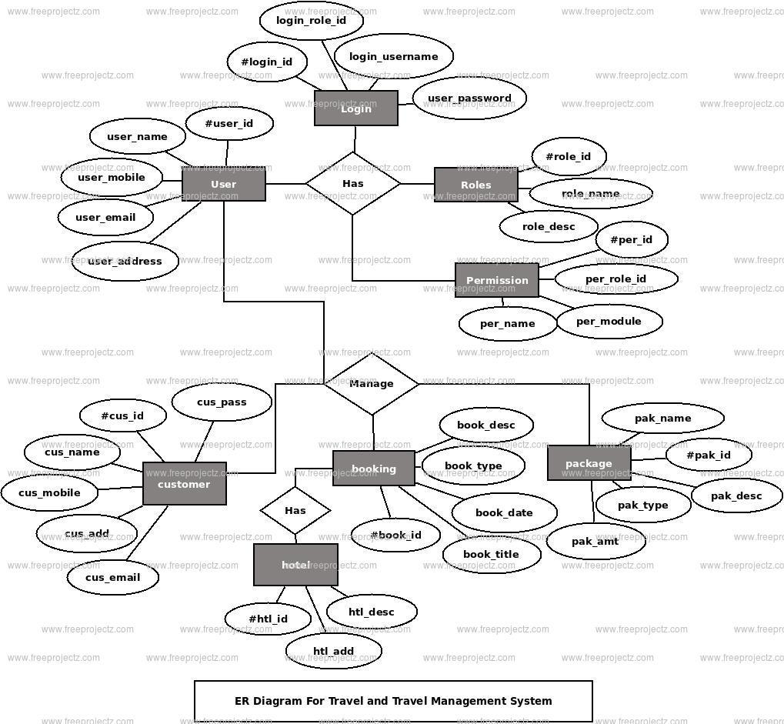

@ 2nd Option

